**<https://randomnerdtutorials.com/getting-started-with-node-red-dashboard/>**

**Node-RED on Raspberry Pi**

This post is an introductory guide to Node-RED. I’ll cover what’s Node-RED, how to install it, how to use the visual interface to create a simple flow.

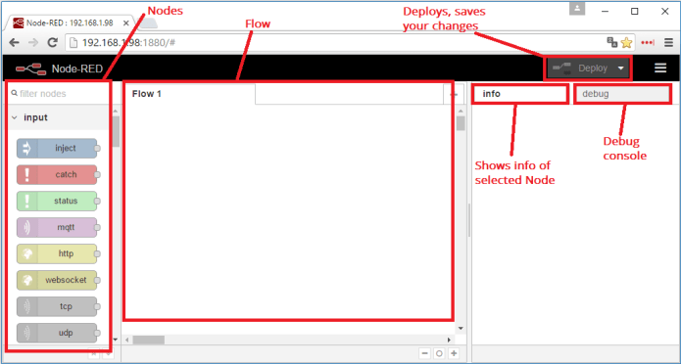

[Getting Started with Raspberry Pi](https://randomnerdtutorials.com/getting-started-with-raspberry-pi/). you should have Raspbian or Raspbian Lite installed in your Raspberry Pi.

[**Node-RED**](http://nodered.org/) is a powerful open source tool for building Internet of Things (IoT) applications with the goal of simplifying the programming component.

Node-RED is open source and developed by IBM.

Node-RED makes it easy to:

* Access your RPi GPIOs
* Establish an MQTT connection with other boards (Arduino, ESP8266, etc)
* Create a responsive graphical user interface for your projects
* Communicate with third-party services (IFTTT.com, Adafruit.io, Thing Speak, etc)
* Retrieve data from the web (weather forecast, stock prices, emails. etc)
* Create time triggered events
* Store and retrieve data from a database

Here’s a library [with some examples of flows and nodes](http://flows.nodered.org/) for Node-RED.

[**http://YOUR_RPi_IP_ADDRESS:1880**](http://YOUR_RPi_IP_ADDRESS:1880)

**http://192.168.1.23:1880**

On the left-side, the blocks are called **nodes**, you can see how it works in the **info** tab.

In the center, you have the **Flow** and this is where you place the nodes.

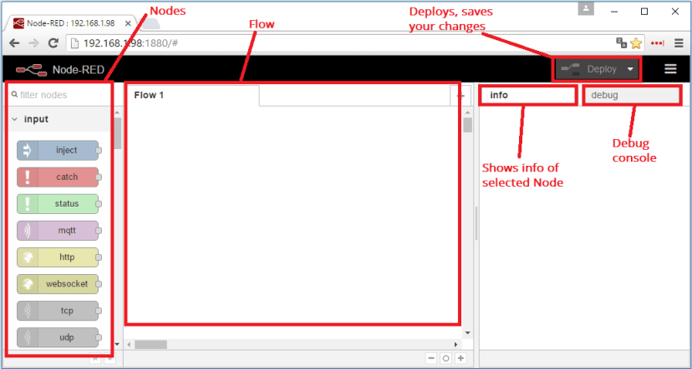

Start by dragging an **Inject**node to your flow. Then, also drag a **Debug** node.

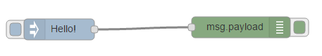

Connect your nodes together. You can drag them to confirm that they are connected.

Now, let’s edit the inject node. Double-click the node. In the figure below you can see different settings you can change.

Select **string** and type **Hello!**.

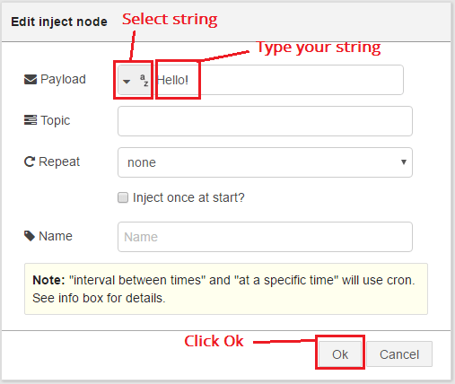

To save your application, you need to click the deploy button on the top right corner.

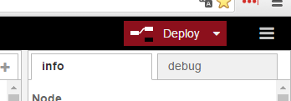

Your application is saved.

Let’s test our simple flow. Open the **debug** window and click the **Inject** node to trigger the “**Hello!**” string.

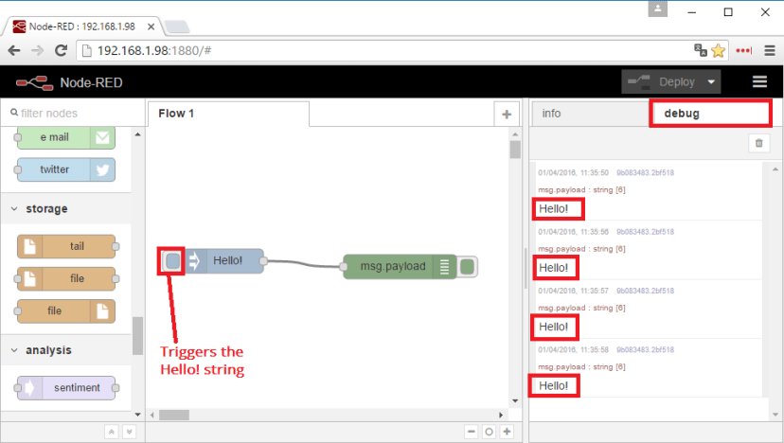

As you can see, our message is being printed in the **debug** window. The purpose of this post is to get you familiar with the Node-RED interface.